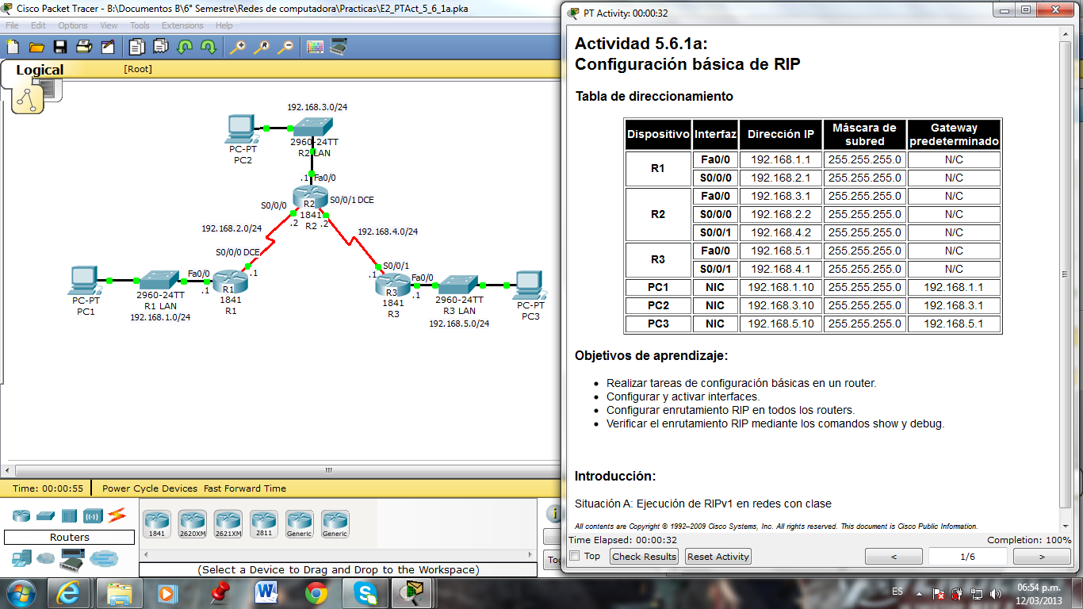

Tabla

|  |  |  |  |  |
| --- | --- | --- | --- | --- |
| Dispositivos | Interfaz | Direccion IP | Máscara de subred | Gateway |
| R1 | Fa0/0 | 192.168.1.1 | 255.255.255.0 | N/C |
| S0/0/0 | 192.168.2.1 | 255.255.255.0 | N/C |
| R2 | Fa0/0 | 192.168.3.1 | 255.255.255.0 | N/C |
| S0/0/0 | 192.168.2.2 | 255.255.255.0 | N/C |
| S0/0/1 | 192.168.4.1 | 255.255.255.0 | N/C |
| R3 | Fa0/0 | 192.168.5.1 | 255.255.255.0 | N/C |
| S0/0/1 | 192.168.4.1 | 255.255.255.0 | N/C |
| PC1 | NIC | 192.168.1.10 | 255.255.255.0 | 192.168.1.1 |
| PC2 | NIC | 192.168.3.10 | 255.255.255.0 | 192.168.3.1 |
| PC3 | NIC | 192.168.5.10 | 255.255.255.0 | 192.168.5.1 |